

# Weapon menu textdraws indexes

Variable:

**ePlayerTextDrawInfo[playerid][e_weapMenu_Icons][ INDEX ]**

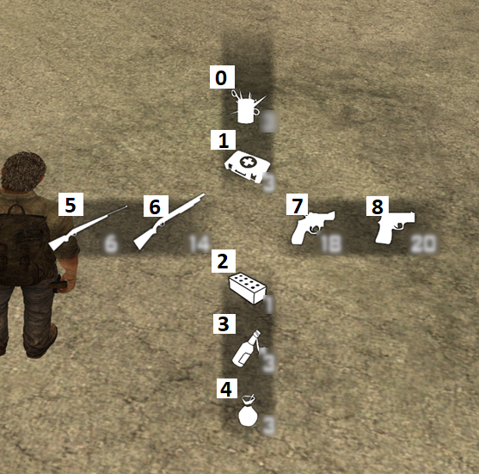

Variable:

**ePlayerTextDrawInfo[playerid][e_weapMenu_swapWeapIcons][ INDEX ]**

